# The Simple Game (Notes)

## Setting Up – N-tier and Modified MVVM

App.xaml  
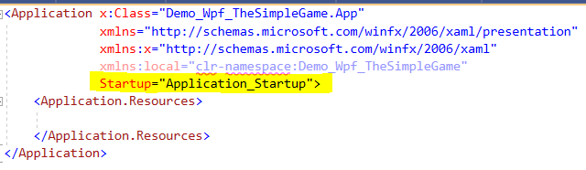

App.xaml.cs  
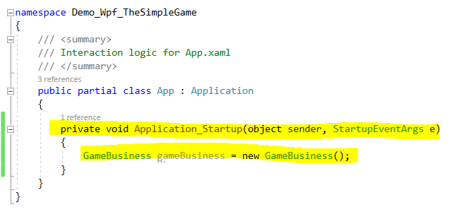

GameBusiness.cs  
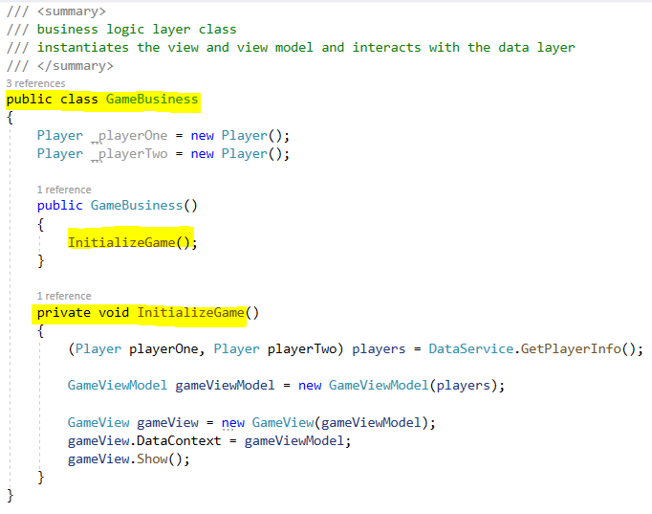

DataService.cs  
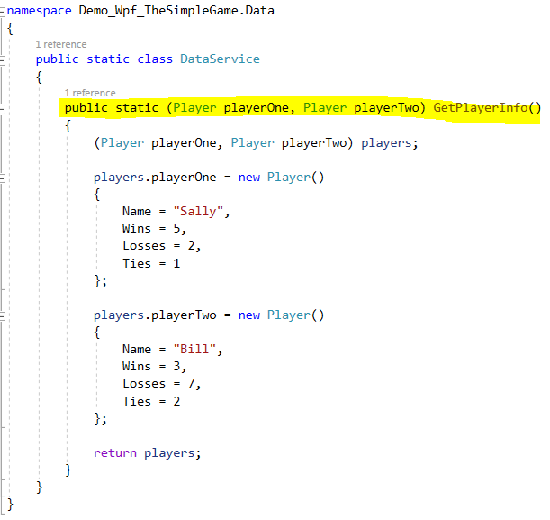

GameViewModel.cs  
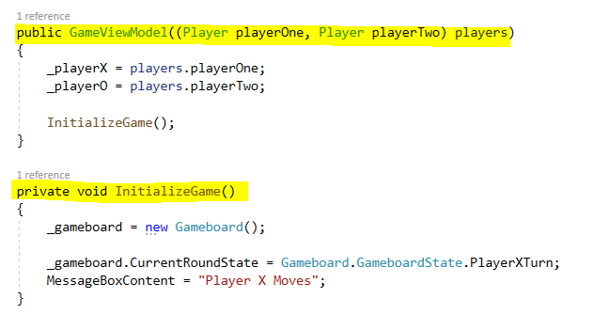

GameView.cs  
